Project Part 3

Database Implementation

Antonio Rios – Ar383

Alex Thomas - Ajt239

Dr. Otte

CS 345: Principles of Database Systems

5/3/2016

**Overview:**

This database was create for the Thomas and Rios Gym. The database helps the gym company keep track of how many gyms there are and all the information pertaining to that gym. The database will also keep track of all employee information and when the employee was hired. The database has two ways of keep track of customers. It keeps track of customer’s information that are not members of the gym and then it of course keeps track of information of customers that are members of the gym. The database also keeps track of each gyms inventory. The database also holds the information for employee schedules, employee payroll, customer retention for each gym and lastly accounting information for each gym. This database will help manage the operations of the gyms. It will also help with creating reports thus reducing the amount of time and training it takes to make the reports.  Hence, making the gyms and the employees at the gyms more efficient.

**Usage of the Database:**

The first table in the database is the gym table. This hold the information of all the gyms in the company. Each gym is assigned its own unique ID. This is the primary key for this table. Then other information about that gym is stored as well. Information such as the address of the gym, the amount of employees at the gym, and lastly the maximum amount of people that can be in the gym. To add a new gym to this table insert is what would need to be used. Example: 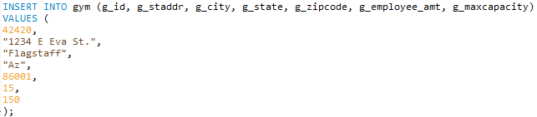

The insert takes in the gym id, the street address, the city, the state, zip code, employees that work there, and lastly the gyms capacity.

The next table that is created in the database is one to manage all of the employees data. It holds the employees name, address, phone number, social security, date of birth, and position in the gym. This is all assigned to a unique employee ID. There were two views created for this table. A management view were anyone in the gym that is a manager can view all employee information. Then an employee view where employees that are not managers can only see basic information such as the ID, name and phone number of their coworkers. To insert into this table it is similar to the gym table. Example: 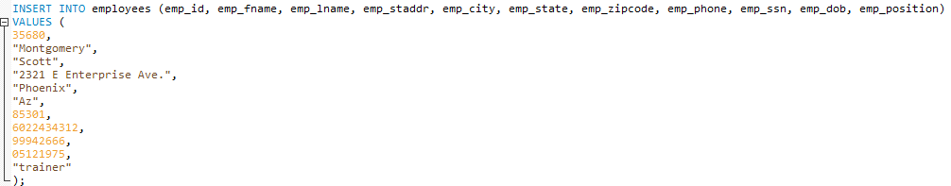

This leads into the two trigger that are implemented into this database. There is a table called employee_log. Every time a new employee is going to be added the trigger save the data and time before the employee is added and then it saves the data and time after the employee is added. This is useful for seeing employee retention 

The next table is the customer table. This table is for customers that are not members of the gym. It holds the customer’s name, email and phone number. This is to be used to advertise becoming a member to these customers. Each customer gets their own unique ID as well. To insert a customer into the table is similar to the past tables. 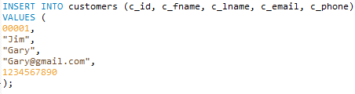

The next table is the membership table. This hold a lot more information than the customer table does. It holds the members name, date of birth, phone number, address, there membership start and end date, and lastly the employee ID of there trainer. This is all assigned to a unique member ID. This information will be later used in other tables to track membership attendance and retention. To Insert a new member:

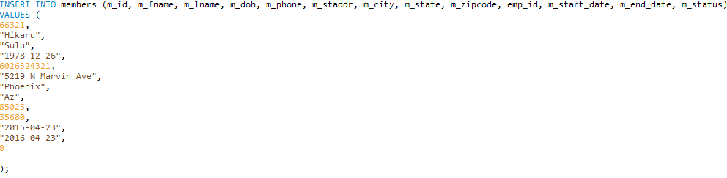

The inventory table is important in order to keep track of what a gym has in stock for its customer and members to use. This is tied into the gym ID to properly show this. This table hold information of how many work out machines the gym has and how many free weights the gym has. To insert new information for a new gym or to insert information for a current gym:

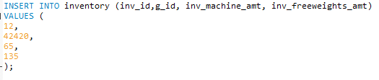

The first number is the inventory id. The second number is the gym id. Then the number of machines that the gym has and lastly the number of weights the gym has.

The next table that was created is a scheduling table. This referenced the employee ID, and the employee position. Then a date, the time the shift starts and the number of hours work that day are stored here.

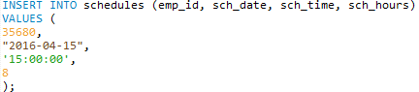

The next table is the payroll table. This table keeps track of the wages per employee. The table references the employee ID. Then it just stores the amount the employee gets paid.

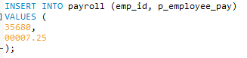

The next table is the attendance table. This table is meant for keeping track of the attendance of the members at each gym. It uses gym id and the member id. It then store the date a member attends and then it stores a count of how many times a member has gone to the gym. This is done for the retention table.

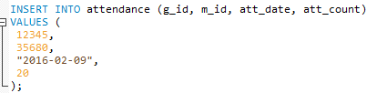

The retention table is to help along with attendance table in keeping members signed up. This uses the count and the member id to help determine if a member has access to certain discounts.

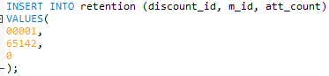

The last table that is created for this database is the accounting table. It keeps track of transactions. Each transaction gets its own unique ID. Then it store the information for membership prices, day to day customer prices, and then the overall maintenance expense for the gym.

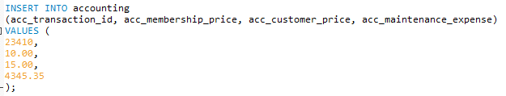

The first number is the transaction ID, followed by the current membership price, then the customer price and lastly the overall maintenance expense.

**TRIGGERS**

In this database there are only two triggers. They both have to do with adding an employee to the employees table. This is to show that the employee was properly added to the table and it can be used later on to see how long an employee has been with the company. When the triggers are activated they both store a message in the employee of table. The first trigger is activated before the employee is inserted into the table. The message is letting the user know that the employee is about to be inserted into the table. After the employee is inserted into the table the second trigger is activated. This is very similar to the first trigger but it lets the user know that employee has be added to the table.